R Markdown : : **CHEAT SHEET**

File path to output document

**5**

What is R Markdown? **1**

**.Rmd files ·** An R Markdown

Find in document

**3 4**

synch publish button to

accounts at rpubs.com,

.rmd Structure

**YAML Header**

Optional section of render (e.g. pandoc)

rmarkdown

Rmd

(.Rmd) file is a record of your

research. It contains the code that a scientist needs to reproduce your work along with the narration that a reader needs to understand your work.

**2**

set

preview location

insert

code

chunk go to code

run code chunk(s)

shinyapps.io

RStudio

Connect

Reload document

options written as key:value pairs (YAML). At start of file

Between lines of - - -

**Text**

Narration formatted with markdown, mixed with:

**Reproducible Research ·** At the click of a 

button, or the type of a command, you 

can rerun the code in an R Markdown file 

to reproduce your work and export the

results as a finished report. 

**Dynamic Documents ·** You can choose 

to export the finished report in a variety of formats, including html, pdf, MS 

Word, or RTF documents; html or pdf

based slides, Notebooks, and more.

Workflow

chunk 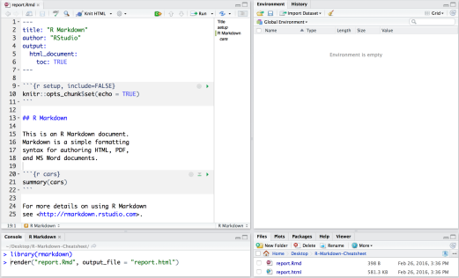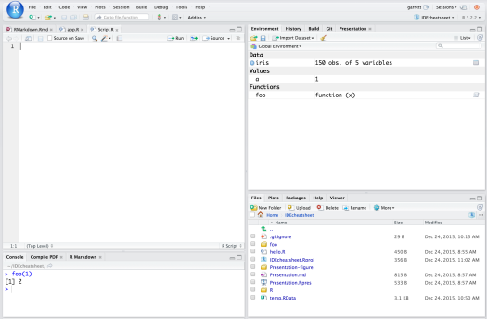

run all

previous

chunks

modify

chunk

options

publish 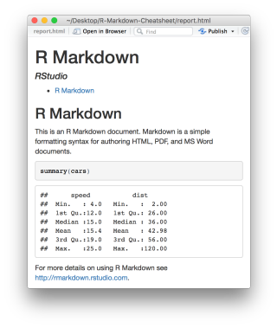

show

outline

run

current

chunk

**Code Chunks** 

Chunks of embedded code. Each chunk:

Begins with **```{r}**

ends with **```**

R Markdown will run the code and append the results to the doc. It will use the location of the .Rmd file as the **working directory**

Parameters

Parameterize your documents to reuse with

different inputs (e.g., data, values, etc.)---

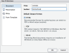

**1**

**Open a new .Rmd file** at File ▶ New File ▶ R Markdown. Use the wizard that opens to pre populate the file with a template **2**

**Write document** by editing template

**3**

**Knit document to create report**; use knit button or **render()** to knit

**4**

**Preview Output** in IDE window

**5**

**Publish** (optional) to web server

**6** 

**7**

render

Use rmarkdown::r**ender()** to render/knit at cmd line. Important args:

1. **Add parameters ·** Create and set parameters in the header as sub values of params

2. **Call parameters ·** Call parameter values in code as params$<name>

3. **Set parameters ·** Set values wth Knit with parameters or the params argument of render():

render("doc.Rmd", params = list(n = 1, d = as.Date("2015-01-01")) 

Interactive Documents

params:

n: 100

d: !r Sys.Date() ---

Today’s date is `r params$d`



**6**

**Examine build log** in R Markdown console **7**

**Use output file** that is saved along side .Rmd

**input** - file to render **output_format**

**output_options** - List of render

options (as in YAML)

**output_file output_dir**

**params** - list of

params to use**envir** - environment

to evaluate code

chunks in

**encoding** - of input file

Turn your report into an interactive Shiny document in 4 steps

1. Add runtime: shiny to the YAML header.

Embed code with knitr syntax **INLINE CODE CODE CHUNKS**

**GLOBAL OPTIONS**

2. Call Shiny input functions to embed input objects. 3. Call Shiny render functions to embed reactive output. 4. Render with rmarkdown::run or click Run Document in

Insert with **`r <code>`**. Results appear as text without code. Built with `r getRversion()` Built with 3.2.3

**IMPORTANT CHUNK OPTIONS**

One or more lines surrounded with **```{r}** and **```**. Place chunk options within curly braces, afer **r**. Insert with 

```{r echo=TRUE} 

getRversion()

```

Set with knitr::**opts_chunk$set()**, e.g. ```{r include=FALSE}

knitr::opts_chunk$set(echo = TRUE) ```

RStudio IDE

---

output: html_document runtime: shiny

---

**cache** - cache results for future knits (default = FALSE) 

**cache.path** - directory to save cached results in (default = "cache/")

**child** - file(s) to knit and then include (default = NULL)

**collapse** - collapse all output into single block (default = FALSE)

**comment** - prefix for each line of results (default = '##')

**dependson** - chunk dependencies for caching (default = NULL)

**echo** - Display code in output document (default = TRUE)

**engine** - code language used in chunk (default = 'R')

**error** - Display error messages in doc (TRUE) or stop render when errors occur (FALSE) (default = FALSE)

**eval** - Run code in chunk (default = TRUE)

**fig.align** - 'lef', 'right', or 'center' (default = 'default')

**fig.cap** - figure caption as character string (default = NULL)

**fig.height, fig.width** - Dimensions of plots in inches

**highlight** - highlight source code (default = TRUE)

**include** - Include chunk in doc afer running (default = TRUE)

**message** - display code messages in document (default = TRUE)

**results** (default = 'markup')

'asis' - passthrough results

'hide' - do not display results

'hold' - put all results below all code **tidy** - tidy code for display (default = FALSE)

**warning** - display code warnings in document (default = TRUE)

```{r, echo = FALSE} 

numericInput("n",

"How many cars?", 5)

renderTable({

head(cars, input$n) 

}) ```

Embed a complete app into your document with shiny::**shinyAppDir()**

Options not listed above: R.options, aniopts, autodep, background, cache.comments, cache.lazy, cache.rebuild, cache.vars, dev, dev.args, dpi, engine.opts, engine.path, fig.asp, fig.env, fig.ext, fig.keep, fig.lp, fig.path, fig.pos, fig.process, fig.retina, fig.scap, fig.show, fig.showtext, fig.subcap, interval, out.extra, out.height, out.width, prompt, purl, ref.label, render, size, split, tidy.opts

NOTE: *Your report will rendered as a Shiny app, which means you must choose an html output format, like* ***html_document****, and serve it with an active R Session.*

RStudio® is a trademark of RStudio, Inc. • CC BY SA RStudio • info@rstudio.com • 844-448-1212 • rstudio.com • Learn more at **rmarkdown.rstudio.com** • rmarkdown 1.6 • Updated: 2016-02

Pandoc’s Markdown Set render options with YAML Write with syntax on the lef to create effect on right (afer render)

When you render, R Markdown

rmarkdown

Plain text

End a line with two spaces to start a new paragraph. *italics* and **bold** `verbatim code`

1. runs the R code, embeds results and text into .md file with knitr

2. then converts the .md file into the finished format with pandoc

r

s

e

b

e

sub/superscript^2^~2~ ~~strikethrough~~ escaped: \* \_ \\

endash: --, emdash: --- equation: $A = \pi*r^{2}$ equation block:

$$E = mc^{2}$$

> block quote

Set a document’s default output format in the YAML header: 





---

output: html_document ---

# Body

| **sub-option** | **description** | l  m  t  h | f  d  p | d  r  o  w | t  d  o | f  t  r | d  m | h  u  t  i  g | d  i  l  s  o  i | y  d  i  l  s | m  a  e  b |
| --- | --- | --- | --- | --- | --- | --- | --- | --- | --- | --- | --- |
| **citation_package** | The LaTeX package to process citations, natbib, biblatex or none |  | X |  |  |  | X |  |  |  | X |
| **code_folding** | Let readers to toggle the display of R code, "none", "hide", or "show" | X |  |  |  |  |  |  |  |  |  |
| **colortheme** | Beamer color theme to use |  |  |  |  |  |  |  |  |  | X |
| **css** | CSS file to use to style document | X |  |  |  |  |  |  | X | X |  |
| **dev** | Graphics device to use for figure output (e.g. "png") | X | X |  |  |  | X | X | X | X | X |
| **duration** | Add a countdown timer (in minutes) to footer of slides |  |  |  |  |  |  |  |  | X |  |
| **fig_caption** | Should figures be rendered with captions? | X | X | X | X |  |  |  | X | X | X |
| **fig_height, fig_width** | Default figure height and width (in inches) for document | X | X | X | X | X | X | X | X | X | X |
| **highlight** | Syntax highlighting: "tango", "pygments", "kate","zenburn", "textmate" | X | X | X |  |  |  |  |  | X | X |
| **includes** | File of content to place in document (in_header, before_body, afer_body) | X | X |  | X |  | X | X | X | X | X |
| **incremental** | Should bullets appear one at a time (on presenter mouse clicks)? |  |  |  |  |  |  |  | X | X | X |
| **keep_md** | Save a copy of .md file that contains knitr output | X |  | X | X | X |  |  | X | X |  |
| **keep_tex** | Save a copy of .tex file that contains knitr output |  | X |  |  |  |  |  |  |  | X |
| **latex_engine** | Engine to render latex, "pdflatex", "xelatex", or "lualatex" |  | X |  |  |  |  |  |  |  | X |
| **lib_dir** | Directory of dependency files to use (Bootstrap, MathJax, etc.) | X |  |  |  |  |  |  | X | X |  |
| **mathjax** | Set to local or a URL to use a local/URL version of MathJax to render equations | X |  |  |  |  |  |  | X | X |  |
| **md_extensions** | Markdown extensions to add to default definition or R Markdown | X | X | X | X | X | X | X | X | X | X |
| **number_sections** | Add section numbering to headers | X | X |  |  |  |  |  |  |  |  |
| **pandoc_args** | Additional arguments to pass to Pandoc | X | X | X | X | X | X | X | X | X | X |
| **preserve_yaml** | Preserve YAML front matter in final document? |  |  |  |  |  | X |  |  |  |  |
| **reference_docx** | docx file whose styles should be copied when producing docx output |  |  | X |  |  |  |  |  |  |  |
| **self_contained** | Embed dependencies into the doc | X |  |  |  |  |  |  | X | X |  |
| **slide_level** | The lowest heading level that defines individual slides |  |  |  |  |  |  |  |  |  | X |
| **smaller** | Use the smaller font size in the presentation? |  |  |  |  |  |  |  | X |  |  |
| **smart** | Convert straight quotes to curly, dashes to em-dashes, … to ellipses, etc. | X |  |  |  |  |  |  | X | X |  |
| **template** | Pandoc template to use when rendering file quarterly_report.html). | X | X |  | X |  |  |  |  | X | X |
| **theme** | Bootswatch or Beamer theme to use for page | X |  |  |  |  |  |  |  |  | X |
| **toc** | Add a table of contents at start of document | X | X | X |  | X | X | X |  |  | X |
| **toc_depth** | The lowest level of headings to add to table of contents | X | X | X |  | X | X | X |  |  |  |
| **toc_float** | Float the table of contents to the lef of the main content | X |  |  |  |  |  |  |  |  |  |

# Header1 {#anchor}

## Header 2 {#css_id}

### Header 3 {.css_class} #### Header 4

##### Header 5

###### Header 6

<!--Text comment-->

\textbf{Tex ignored in HTML} <em>HTML ignored in pdfs</em>

<http://www.rstudio.com>

| **output value** | **creates** |
| --- | --- |
| **html_document** | html |
| **pdf_document** | pdf (requires Tex ) |
| **word_document** | Microsof Word (.docx) |
| **odt_document** | OpenDocument Text |
| **rtf_document** | Rich Text Format |
| **md_document** | Markdown |
| **github_document** | Github compatible markdown |
| **ioslides_presentation** | ioslides HTML slides |
| **slidy_presentation** | slidy HTML slides |
| **beamer_presentation** | Beamer pdf slides (requires Tex) |

[link](www.rstudio.com) Jump to Header 1 image:

Customize output with sub-options (listed to

---

**Indent 2 spaces**

**Indent 4 spaces**

![Caption](smallorb.png)

* unordered list

+ sub-item 1

+ sub-item 2

- sub-sub-item 1

* item 2

the right):

**html tabsets**

output: html_document: code_folding: hide toc_float: TRUE

---

# Body

Continued (indent 4 spaces)

1. ordered list

2. item 2

Use tablet css class to place sub-headers into tabs

# Tabset {.tabset .tabset-fade .tabset-pills} ## Tab 1

i) sub-item 1

A. sub-sub-item 1 (@) A list whose numbering continues afer

(@) an interruption

text 1

## Tab 2

text 2

### End tabset

**Tabset**

**Tab 1 Tab 2**

text 1

**End tabset**

Term 1

: Definition 1

Create a Reusable Template

Table Suggestions Citations and Bibliographies

| Right | Lef | Default | Center | |------:|:-----|---------|:------:| | 12 | 12 | 12 | 12 | | 123 | 123 | 123 | 123 |

1. **Create a new package** with a inst/rmarkdown/templates directory

2. In the directory, **Place a folder** that contains: **template.yaml** (see below)

Several functions format R data into tables

Create citations with .bib, .bibtex, .copac, .enl, .json, .medline, .mods, .ris, .wos, and .xml files

---

| 1 | 1 | 1 | 1 |

- slide bullet 1

- slide bullet 2

**skeleton.Rmd** (contents of the template) any supporting files

3. **Install the package**

1. **Set bibliography file** and CSL 1.0 Style file (optional) in the YAML header 2. **Use citation keys in text** 

bibliography: refs.bib csl: style.csl

---

(>- to have bullets appear on click) horizontal rule/slide break: ***

A footnote [^1]

[^1]: Here is the footnote.

4. **Access template** in wizard at File ▶ New File ▶ R Markdown template.yaml 

---

name: My Template

—

data <- faithful[1:4, ]

```{r results = 'asis'}

knitr::**kable(**data, caption = "Table with kable”**)** ```

```{r results = "asis"}

print(xtable::**xtable(**data, caption = "Table with xtable”**)**, type = "html", html.table.attributes = "border=0")) ```

```{r results = "asis"}

stargazer::**stargazer(**data, type = "html", title = "Table with stargazer"**)**

```

Smith cited [@smith04].

Smith cited without author [-@smith04].

@smith04 cited in line.

3. **Render.** Bibliography will be 

added to end of document

Learn more in

the **stargazer,**

**xtable**, and **knitr**

packages.

RStudio® is a trademark of RStudio, Inc. • CC BY SA RStudio • info@rstudio.com • 844-448-1212 • rstudio.com • Learn more at **rmarkdown.rstudio.com** • rmarkdown 1.6 • Updated: 2016-02